W/C 18/02/2019 Week 35
 | Performance / Targets | Week 34
  Area | Total | Target
  Admissions
  Gaming Handle
  ER Handle
  Gaming Win/Loss
  ER Win/Loss
  Gaming Margin
  ER Margin
  Slots Coin In
  Slots Income
  Card Room Income
  Food Income
  Bar Income
  Total Income
 | Promotions Today & Coming Soon | February Stamp Card promotion runs until March 3rd, customers need to get 5 stamps in one calendar week (Mon to Sun), 1500 play points each time they do this.
 | Guests and Visitors | Head of Operations and change will be visiting the club on Thursday.  The Gambling Commission will be making a visit on Monday 25th. Make sure you are up to speed with your Licensing Objectives.
 | EDD / Responsible Gambling etc | Ensure managers are getting all messages on customer profiles Important that RG conversations take place and any concerns share them with GS/DM’s.
 | Team Updates | Please remember scan in with your fingerprint as well as clocking in this is a trial with both systems running side by side. If you haven’t had your finger scanned please let your line manager know.  We are actively recruiting for gaming team, cashdesk, reception and F & B with interviews already underway
 | H&S | COSHH training is now live on my hub make sure this is completed asap also a folder with COSHH information that needs to be read & signed by everyone. If you haven’t done this yet please make it known to pit boss.
 | Digital / GrosvenorCasinos.com  Weekly FTD’s | New trial offer for G1 digital sign up: Sign up for G1, deposit £10 via bank card, create username and password for grosvenorcasinos.com and receive £10 gaming chip.  In club FTD offer: deposit £20 for a £5 free bet on ER/Slots.  Online bonus match plays: up to £20, £80, £100 for first 3 deposits.  Sports offer: 3 free £10 bets when you bet £10.  Conversation starter tips: Try using some of these to start the right conversations and drive digital.  Neutral opening- “Hey, how’s your night going?” “Having a good night?”  Guiding the conversation- “Have you seen our online offers?” “Do you bet on the football/horses etc?”  Informing statement- “The game you are playing is available on our website” “You get bonus funds when you deposit funds with us”
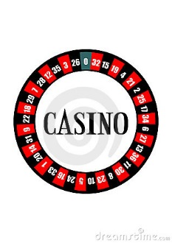 | Top Priorities and Focus for the shift | Converting customers to our new G1 account so they can take advantage of all the offers
 | F&B Updates/Promos | The duty manager must approve all food comps before processing on till, receipt must be taken asap to that duty manager to sign.
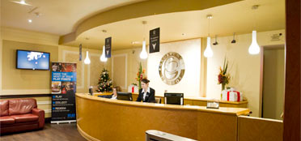 | Reception Updates/Promos/ Cust Ex | 3 responses this past week with some positive comments score is cumulative so explains the low overall score keep up the good work and raise our score further.  - I really enjoyed my time - all staff were friendly  - Pleasant evening-very enjoyable  - Met up with friends had an enjoyable night

